**Cyber Crop Market**

A project developed using spring boot

AUCA 2023

Uwineza Aline

23678

**Table of Contents**

**1.** **Introduction** 3

**2.** **Project Requirements** 3

II. Non-functional Requirements: 3

III. Specific Constraints or Limitations 4

**3.** **Project Plan** 5

I. Project Scope: 5

II. Timeline: 5

III. Resources 5

**4.** **Database Schema** 6

**5.** **User Documentation** 7

**6.** **Technical Documentations** 8

**7.** **Conclusion** 10

# **Introduction**

Introducing "Cyber Crop Market" – an innovative web application uniting local farmers and discerning customers in a seamless online marketplace. Developed with the Spring Boot framework, our cooperative platform empowers farmers with intuitive product management, while customers enjoy a convenient avenue to effortlessly procure fresh, locally sourced produce. Bridging the gap between producers and consumers, our mission is to foster sustainable agriculture and advocate for the support of local farmers. Experience a user-friendly hub where farmers showcase their inventory and customers easily access and purchase quality crops, all within the Cyber Crop Market.

# **Project Requirements**

**I. Functional Requirements:**

* Product Listing: The application should provide a platform for farmers to register and list their products for sale, including product name, description, price, and quantity.
* Product Search: The application should allow users to search for products based on name, category, and location.
* Purchase and Checkout: The application should allow users to purchase products. The application should provide a confirmation of purchase to the user.
* User Authentication: The application should provide a secure authentication system for users to create and manage their accounts.
* Admin Dashboard: The application should provide an admin dashboard for managing product listings, users, and orders.

## **II. Non-functional Requirements:**

* Performance: The application should be able to handle a large number of users and product listings without any performance issues.
* Security: The application should be designed with security in mind, including user authentication.
* Availability: The application should be available 24/7, with minimal downtime for maintenance and updates.
* Usability: The application should have a user-friendly interface, with clear navigation and easy-to-use features.
* Compatibility: The application should be compatible with different web browsers and devices.
* Scalability: The application should be designed in a way that allows for easy scalability in the future, as the number of users and product listings increases.
* Accessibility: The application should be designed to be accessible to users with disabilities, in compliance with relevant accessibility standards.

These requirements are intended to ensure that the Cyber Crop Market project meets the needs of its users and stakeholders, and delivers a high-quality, secure, and user-friendly platform for buying and selling produce.

## **Specific Constraints or Limitations**

* Payment Options: The application currently supports doesn’t support multiple payment methods, limiting customers to a specific payment option. Integration with additional payment gateways or alternative payment methods is not available at this time.
* Order Management System: The application does not include an order management system that allows customers to track their purchases or receive notifications about their orders. As a result, customers will not have real-time updates on the status of their purchases. They will only know the date their purchases will ne delivered.
* Inventory Management: While the application provides a platform for farmers’ Admin to update their product listings and prices, it does not offer real-time inventory updates. Therefore, it is crucial for farmers to promptly update their inventory to avoid potential discrepancies between product availability and customer orders.
* Messaging System: The application does not have a built-in messaging system for direct communication between farmers and customers. Farmers and customers will need to rely on external means of communication for inquiries, feedback, or any other interactions.
* Administrative Product Registration: Only the admin has the authority to register products on the platform. Farmers are unable to add new products directly, and all product additions or modifications require administrative intervention.
* Limited Customization: The current version of the application offers limited customization options for farmers to showcase their unique branding or product information. Farmers are advised to provide detailed descriptions and high-quality images within the given constraints.
* Scalability: While the application is designed to accommodate a significant number of farmers and customers, there may be scalability challenges as the user base grows. It is essential to monitor and optimize the application's performance to ensure smooth operation under increased traffic and data load.
* Security and Privacy: The application implements standard security measures to protect user data and transactions. However, it is important to acknowledge that no system is entirely immune to security breaches. Users should exercise caution when sharing personal or financial information online.

# **Project Plan**

## **Project Scope**:

* Develop an Cyber Crop Market platform that connects farmers with customers.
* Provide a platform for the admin to register, list their products, and manage inventory.
* Enable customers to browse and purchase products.
* Implement an admin dashboard for product management and order tracking.

## **Timeline:**

* Phase 1: Requirements Gathering and Planning (1 day)
* Phase 2: Application Development (1.5 weeks)
* Phase 3: Testing and Quality Assurance (1 weeks)
* Phase 4: Deployment and Launch (1 day)
* Phase 5: Post-launch Monitoring and Maintenance (Ongoing)

## **Resources**

* Myself: As the project manager, The developer, The designer, The engineer, The system and database administrator of this project.
* A computer: used for all development and deployment of this project.
* YouTube, Google and ChatGpt: These resources were used to learn how spring boot works and they provided me with the basics I needed to start and implement my project.

# **Database Schema**

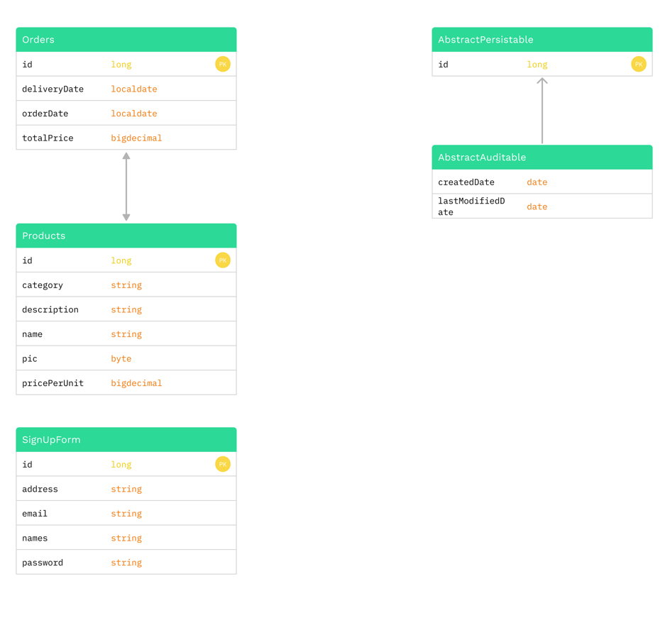

# **User Documentation**

* **Accessing the Application:**
  + Open a web browser and enter the URL of the Cyber Crop Market application.
  + The application's page will be displayed.
* **User Registration**:
  + On the page, click on the "Sign Up"or “Login” button.
  + Fill in the required registration information, including your name, email address, and password.
  + Click on the "Register" button to create your account.
* **User Login:**
* On the homepage, click on the "Login" button.
* Enter your registered email address and password.
* Click on the "Login" button to access your account.
* **Navigating the Application:**
* Dashboard: After logging in, you will be directed to the user dashboard. This is the central hub for all your activities.
* Product Listings: Browse through the available products displayed on the product listing page. Each product will have details such as name, price, picture and description.
* **Features and Functionality:**
* Product Search: Use the search bar to find specific products by name or category.
* Product Details: Click on a product to view detailed information and images.
* **Contacting Customer Support:** If you encounter any issues or have questions while using the application, you can contact our customer support team at the contacts listed down on the footer of the application pages.
* Please note that you should keep your login credentials confidential to protect your account's security.

**NB**: If the user is an admin, they will need to login with the following credentials:

Email: [admin@gmail.com](mailto:admin@gmail.com)

Password: I am the Admin

# **Technical Documentations**

1. **Architecture Overview**

The Cyber Crop Market application follows a three-tier architecture, consisting of a presentation layer, a business logic layer, and a data persistence layer.

1. **Technology Stack**

a. Backend:

* Framework: Spring Boot
* Programming Language: Java
* Database: Mysql
* ORM: Hibernate

b. Frontend:

* HTML
* CSS
* JavaScript

c. Dependencies:

* Spring boot data JPA
* Thymeleaf
* Spring Web
* Spring boot Devtools
* Postgresql
* Lombok
* spring-boot-starter-validation

1. **Application Components**

a. **Presentation Layer:**

* Frontend: The frontend component is responsible for handling user interactions and rendering the user interface.

b. **Business Logic Layer:**

* Controllers: The controllers receive and process HTTP requests, handle authentication, and manage the flow of data.
* Services: The services encapsulate the application's business logic, handle data processing, and interact with the data persistence layer.
* Data Transfer Objects (DTOs): DTOs are used for transferring data between the presentation layer and the business logic layer.

c. **Data Persistence Layer:**

* Entities: The entities represent the application's data model and are mapped to database tables using Hibernate.
* Repositories: The repositories provide methods for querying and manipulating data in the database.

1. **Application Workflow**

a. User Interaction: Users interact with the frontend interface to browse products, and buy them.

b. Controller Handling: The controllers receive HTTP requests from the frontend, validate inputs, and invoke the corresponding service methods.

c. Service Processing: The services handle the business logic, such as product listing retrieval and order processing.

d. Data Persistence: The services interact with the database through repositories to perform CRUD operations and update the data as required.

1. **Third-Party Libraries and Frameworks**

a. Spring Boot: Provides a robust framework for building Java applications, including features like dependency injection, MVC architecture, and security.

b. Hibernate: Enables object-relational mapping and simplifies database interactions.

c. Redux: A state management library for JavaScript applications, ensuring predictable state changes and centralizing data management.

d. Bootstrap: A CSS framework that facilitates responsive and visually appealing UI design.

1. **Deployment**

The application was deployed on a cloud platform called Heroku.

# **Conclusion**

The Cyber Crop Market application is an innovative platform that aims to connect farmers with customers, providing a convenient and efficient way to buy and sell produce. With its user-friendly interface, secure authentication system, and robust features, the application streamlines the process of purchasing fresh and locally sourced products.

Throughout this documentation, we have outlined the project requirements, including the purpose, expected outcomes, and specific constraints of the application. We have also provided a project plan that outlines the scope, timeline, and resources required for successful implementation.

Furthermore, we have presented the database schema, illustrating the table definitions and relationships, ensuring efficient data management and retrieval. The user documentation guides users through the application, explaining the login process, navigation, and available features.

Additionally, the technical documentation offers insights into the application's architecture, implementation details, and the technologies used. It provides a comprehensive understanding of the application's components, workflow, and integration with third-party libraries and frameworks.

The Cyber Crop Market application opens up new opportunities for farmers to reach a broader customer base and for customers to access fresh, high-quality products conveniently. By leveraging technology, the application aims to bridge the gap between farmers and consumers, fostering a sustainable and thriving agricultural community.

With its robust functionality, intuitive user experience, and reliable technical infrastructure, the Cyber Crop Market application is poised to revolutionize the way people buy and sell produce. We are excited to embark on this journey and invite you to join us in supporting local farmers and embracing a healthier and more sustainable food system.

Thank you for your interest in the Cyber Crop Market application.

23678 : <https://github.com/alineuwineza/Cyber_Crop_Market.git>